MAP COLORING PROBLEM
Aim
To implement the Map Coloring Problem using a Constraint Satisfaction Problem (CSP) in Python, where adjacent regions are assigned different colors.
Python Code
# Map Coloring using Constraint Satisfaction Problem (CSP)

def is_valid(region, color, assignment, neighbors):
# Check whether the color is different from all neighboring regions
for neighbor in neighbors[region]:
if neighbor in assignment and assignment[neighbor] == color:
return False
return True

def map_coloring(regions, colors, neighbors, assignment={}):
# If all regions are assigned, solution is found
if len(assignment) == len(regions):
return assignment

# Select an unassigned region
region = next(r for r in regions if r not in assignment)

# Try each available color
for color in colors:
if is_valid(region, color, assignment, neighbors):
assignment[region] = color

result = map_coloring(
regions, colors, neighbors, assignment
)

if result:
return result

# Backtracking
del assignment[region]

return None

# Regions
regions = ['A', 'B', 'C', 'D']

# Available colors
colors = ['Red', 'Green', 'Blue']

# Neighboring regions
neighbors = {
'A': ['B', 'C'],
'B': ['A', 'C', 'D'],
'C': ['A', 'B', 'D'],
'D': ['B', 'C']
}

# Find solution
solution = map_coloring(regions, colors, neighbors)

# Display result
if solution:
print("Map Coloring Solution:")
for region, color in solution.items():
print(region, "->", color)
else:
print("No solution exists.")

Output:
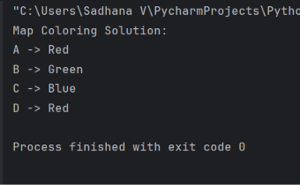
Result
Thus, the Map Coloring Problem was successfully implemented using CSP and backtracking in Python, ensuring that no two adjacent regions have the same color

